 | International Round Table  CRISIS MANAGEMENT  IN THE TIME OF COVID 19  improvise, adapt and overcome  9th of April 2021 | 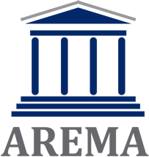

Registration form

Participant:

Affiliation and position:

Exact e-mail address:

Herby I declare that I will join the International round table “Crisis management in the time of COVID 19” as
(please mark one of the two options)

1. An active speaker with submitted article titled:

2. Participant without submitted article:

Date:

Name and Sign:

